EX NO:07| CREDIT CARD PROCESSING SYSTEM
DATE: |
AIM:
To draw the diagrams [usecase, activity, sequence, collaboration, class, statechart,
component, deployment, package ] for Credit Card Processing .

SL.NO SOFTWARE REQUIREMENTS SPECIFICATION
1.0 Hardware Requirements
1.1 Software Requirements
1.2 Problem Analysis and Project Plan
1.3 Project description
1.4 Reference

1.0 HARDWARE REQUIREMENTS:
Intel Pentium Processor I3/I5
1.1 SOFTWARE REQUIREMENTS:
Rational rose / Argo UML

1.2 PROBLEM ANALYSIS AND PROJECT PLANNING
The Credit Card Processing System which is use to purchasing an item from any shop mall,
and it is used to maintain the limitation of credit card balance and current transaction process could
be update via credit card machine. This project mainly used for large amount of item can be easy
to buy from anywhere and required transaction process should be maintained them.

1.3 PROJECT DESCRIPTION:
This software is designed for supporting the computerized credit card processing
System .In this system, the cardholder purchases items and pays bill with the aid of the credit card.
The cashier accepts the card and proceeds for transaction using the central system. The bill is
verified and the items are delivered to the cardholder.

1.4 REFERENCES:
IEEE Software Requirement Specification format.
USE CASE DIAGRAM:
This diagram will contain the actors, use cases which are given below
Actors: Cardholder, Cashier, Central system.
Use case: Receive bill, Give card, Enter card number, Enter amount, Transaction,
Receive Receipt.

CLASS DIAGRAM:
This diagram consists of the following classes, attributes and their operations.
CLASSES ATTRIBUTES OPERATIONS
Central system product name,
product details
Print bill(),
Validate card()
Cashier Product name,
Cost of the product
Enter amount(),
Swipe card(),
Print bill(),
Deliver product()
Card holder Item purchased,
Validate card
Give card(),
Sign bill()

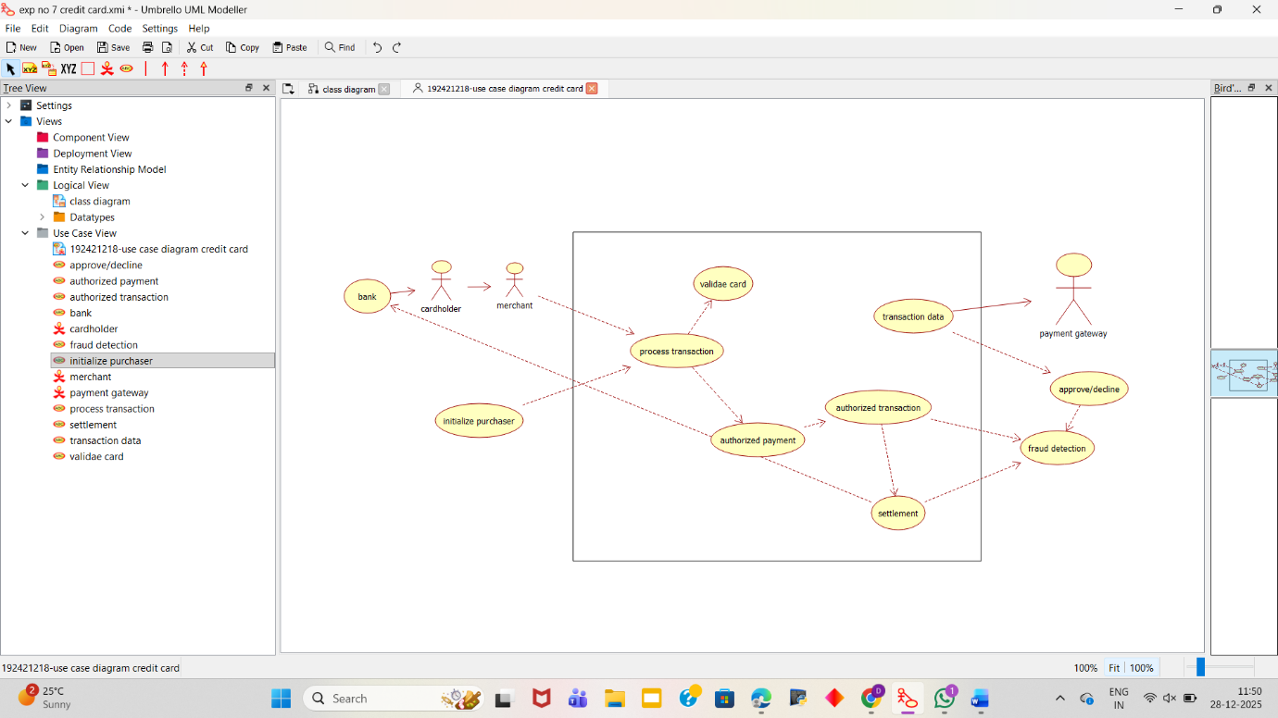
ACTIVITY DIAGRAM:
This diagram will have the activities as Start point ,End point, Decision boxes as given
below:
Activities: Receive Bill, Give card, Enter the card number, Enter the amount,
Transaction, Receive Receipt
Decision box: Verification of card
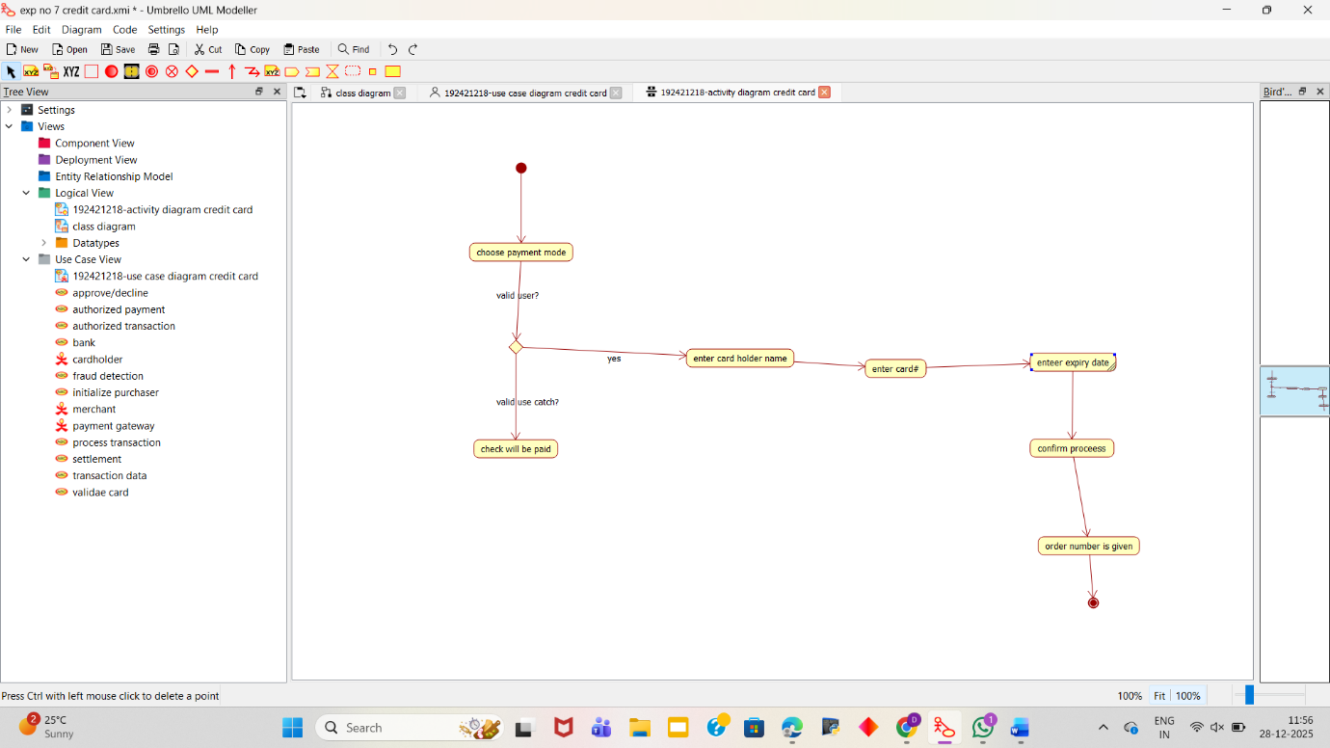

SEQUENCE DIAGRAM:
This diagram consists of the objects, messages and return messages.
Object: Card Holder,Cashier , Central systemo
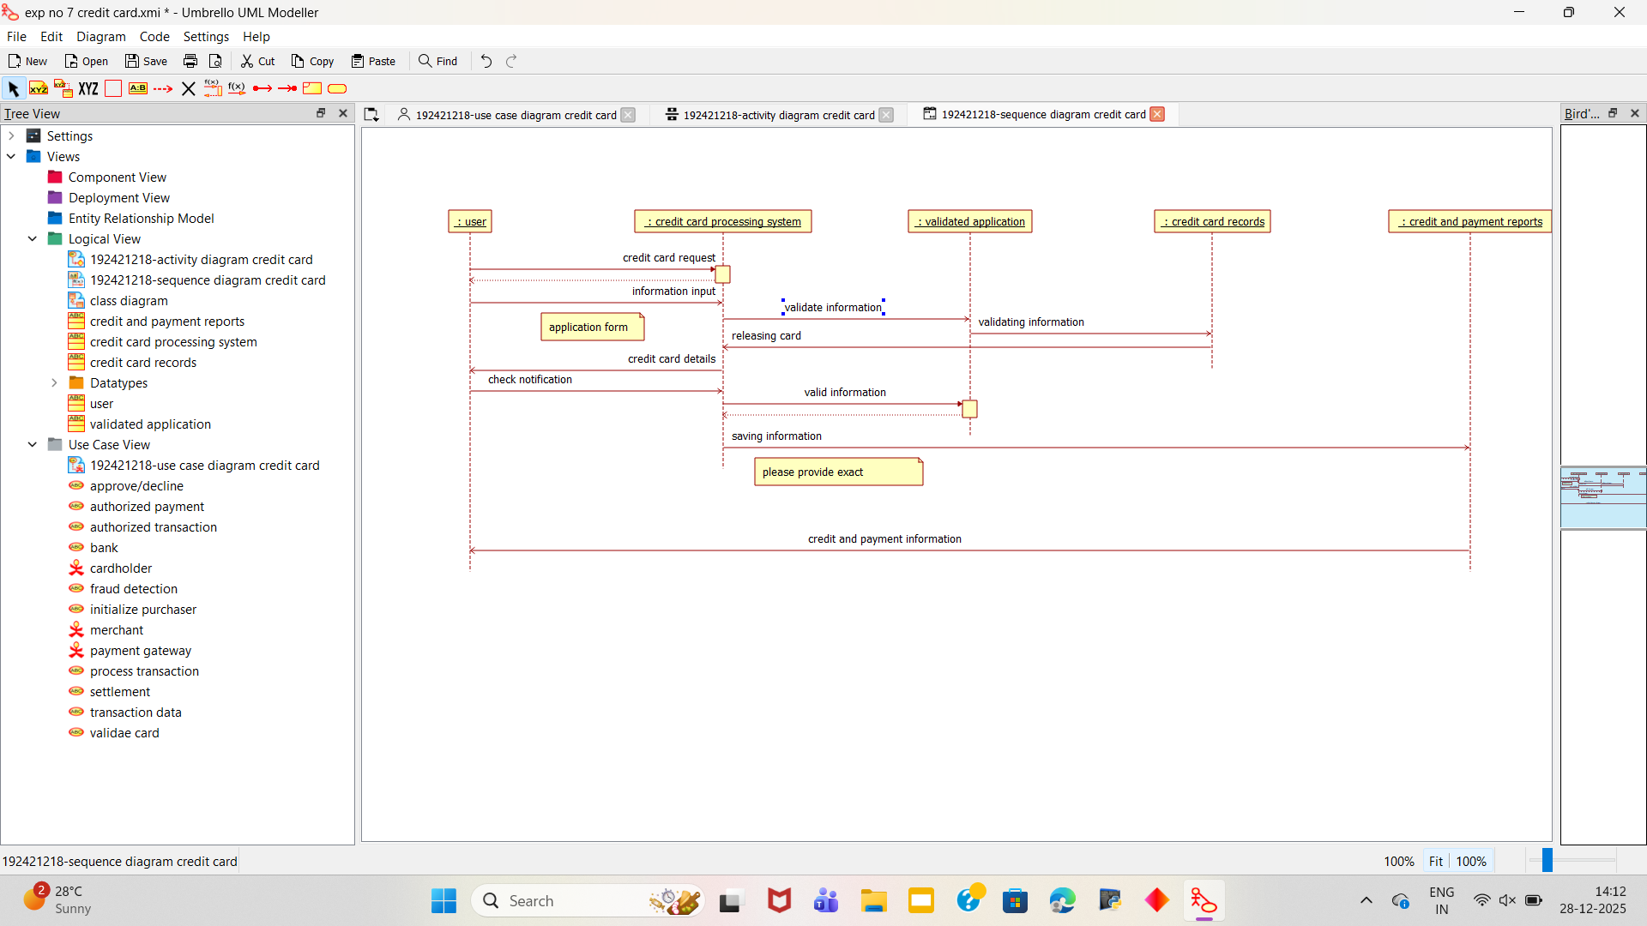

COLLABORATION DIAGRAM:
This diagram contains the objects and actors. This will be obtained by the completion of
the sequence diagram and pressing the F5 key.
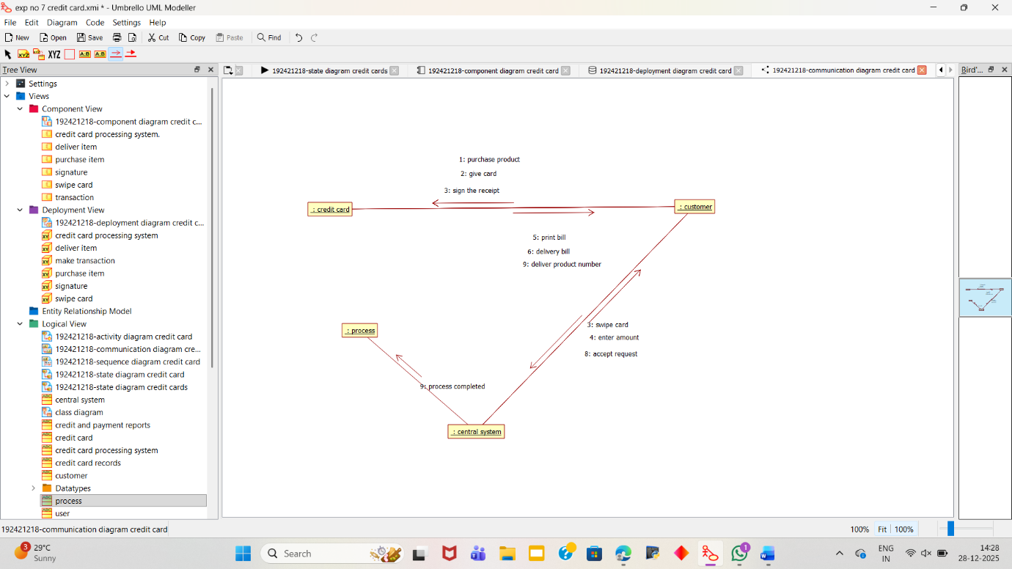

STATE CHART DIAGRAM:
It is a technique to describe the behavior of the system. It describes all the possible states
that a particular object gets into the object oriented technique. State diagram are drawn for a single
class to show to the lifetime behaviour of a single objects
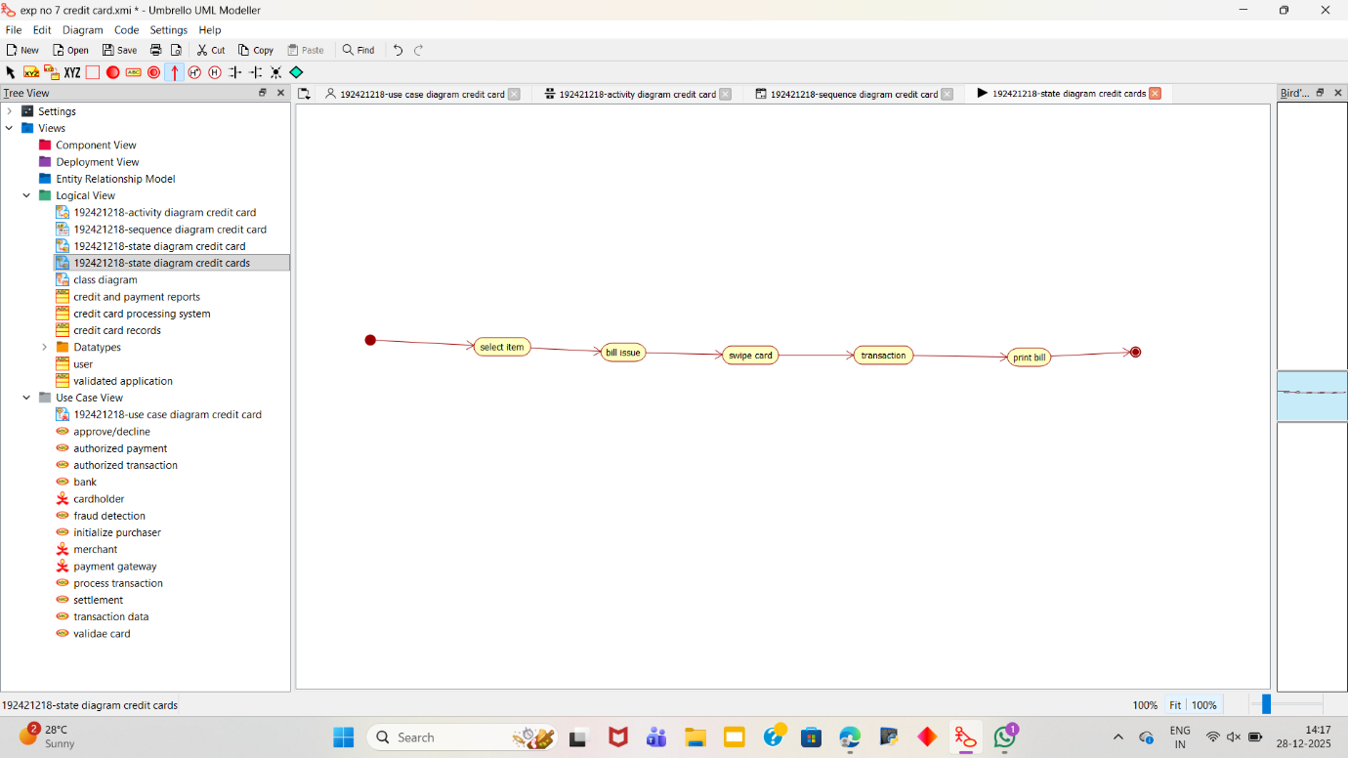
COMPONENT DIAGRAM:
The component diagram is represented by figure dependency and it is a graph of design of
figure dependency. The component diagram's main purpose is to show the structural relationships
between the components of a systems. It is represented by boxed figure. Dependencies are
represented by communication association
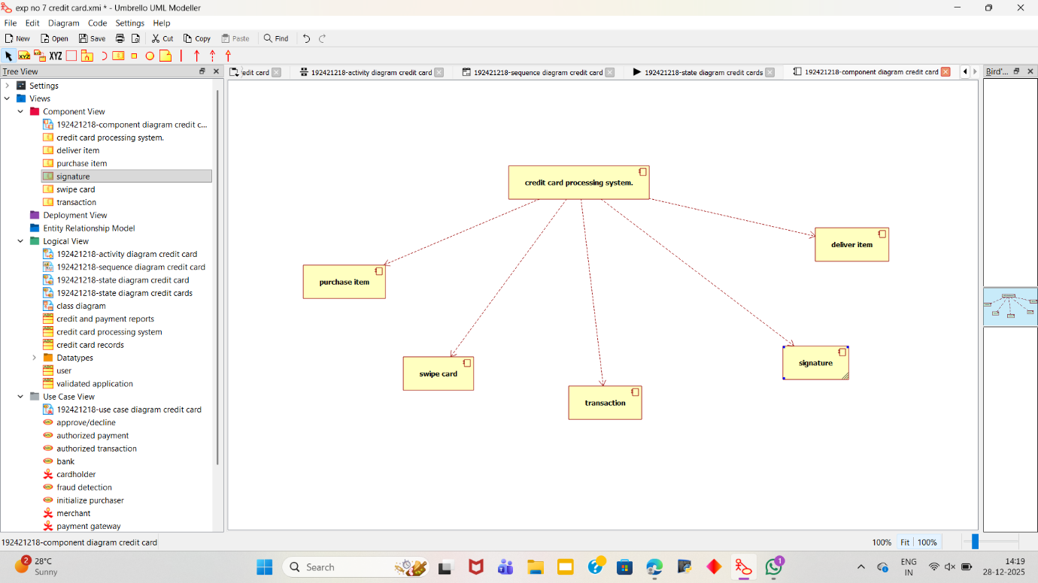

DEPLOYMENT DIAGRAM:
A deployment diagram in the unified modeling language serves to model the physical
deployment of artifacts on deployment targets. Deployment diagrams show "the allocation of
artifacts to nodes according to the Deployments defined between them. It is represented by 3-
dimentional box. Dependencies are represented by communication association.
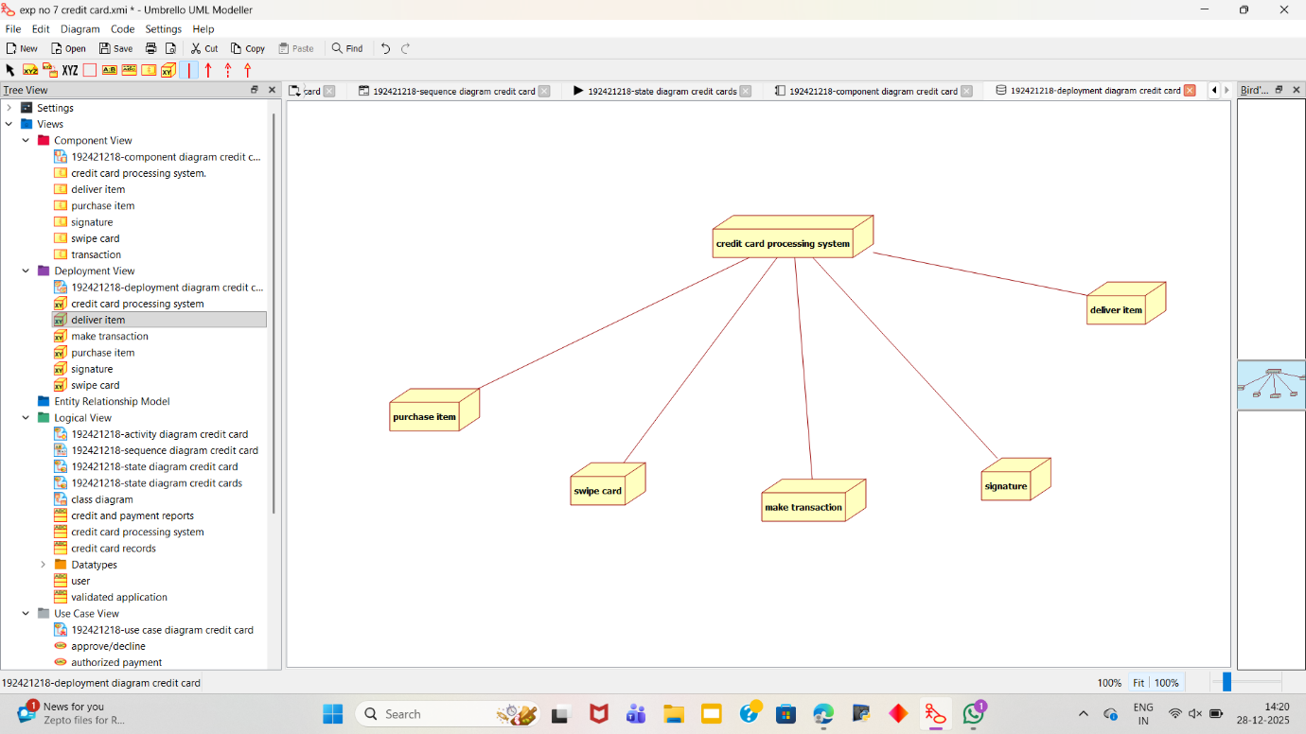
PACKAGE DIAGRAM:

A package diagram in unified modeling language that depicts the dependencies
between the packages that make up a model. A Package Diagram (PD) shows a grouping of
elements in the OO model, and is a Cradle extension to UML. PDs can be used to show groups of
classes in Class Diagrams (CDs), groups of components or processes in Component Diagrams
(CPDs), or groups of processors in Deployment Diagrams (DPDs).
There are three types of layer. They are
o User interface layer
o Domain layer

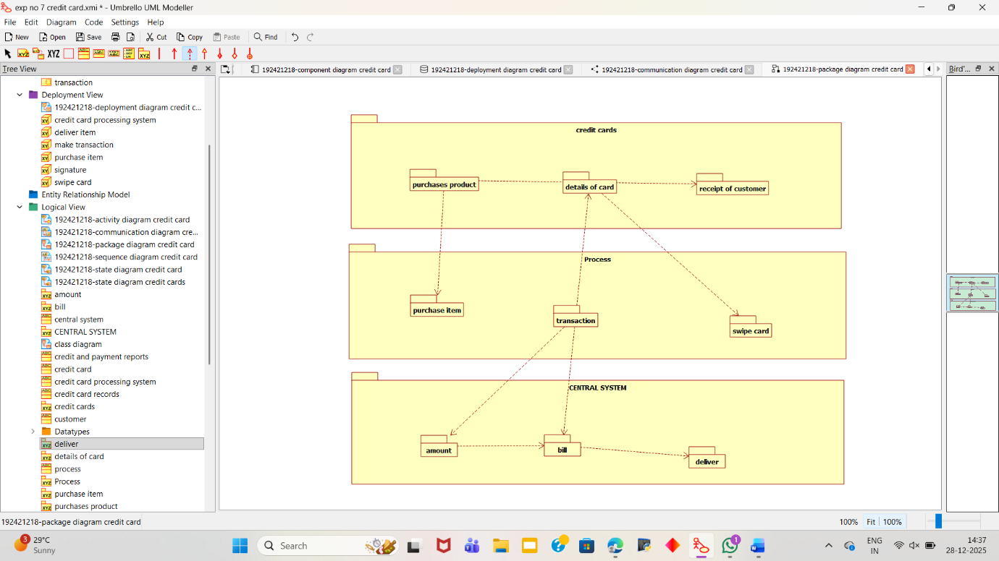

RESULT:
Thus the diagrams[use case, activity, sequence, collaboration, class, state chart,
component, deployment, package] for the credit card processing system has been designed,
executed and output is verified.

